**miHealth2**

**Client Information**

**Bio-Resonance Therapy**

Leanne Barsby

15 Edgewater Court

Murrumba Downs QLD 4503

0409 969 992

Please complete the following, take a copy by scan or photograph and return prior to your appointment.

Name:_____________________________________________________________

Date:____________________________________DOB:_____________________

Address:__________________________________________________________________

Contact Number:____________________ Email:__________________________

Before undergoing BioResonance therapy it is important for us to have the following information:

**Please tick if the following applies to you:**

|  |  |  |
| --- | --- | --- |
| 🞏 Pacemaker or battery / electrically operated implant? | 🞏 Metal implants?  If so, where?  ___________________ | 🞏 Hearing Aids? |
| 🞏 Any chance of pregnancy? / Breastfeeding? | 🞏 Organ transplant recipient? | 🞏 On heartbeat medication? |

Are you taking: **(please tick if the following applies to you)**

|  |  |  |  |
| --- | --- | --- | --- |
| 🞏 Blood thinning medication?  If so, what? ___________________ | 🞏 Blood Pressure Medication?  If so, what? ____________________ | 🞏 Epilepsy or seizure medication?  If so, what? _________________ | 🞏 Any mental illness medication? (i.e. antidepressants or anti-psychotics)  If so, what? ______________ |

____________________________________________________________________________________

Additional information: **(please tick if the following applies to you)**

|  |  |  |  |
| --- | --- | --- | --- |
| 🞏 Diabetic? | 🞏 Hypoglycaemic? | 🞏 Do you have Haemophilia? | 🞏 Do you have anaphylactic reactions?  If so, to what?  ______________ |

***I acknowledge that I have not been given a guarantee of success for the removal of my symptoms and issues with the use of Bio-Resonance. I understand that the success of the therapy and the time frame required is dependent on the ability of my body to respond to this therapy and compliance with the given advice.***

*** **DISCLAIMER:** This is not medical advice ***

Sunlight Amount of natural sunlight you receive daily outside? __________ Amount of sunlight you receive daily through windows?__________

Hours spent daily under fluorescent lights?__________

Eyewear Do you wear contact lenses?________ Glasses?_______ If so, how many hours

per day?___________

Electromagnetic Exposure:

How many hours do you spend daily:

Watching TV? __________ Working on a computer, tablet or mobile? _________ Talking on a mobile phone? __________ Wearing a headset? _________

Wearing a wrist-watch (with battery)? ________

Do you live or work within 5 km of a cell phone tower? YES / NO

Do you live or work within 30m or less of a power transformer (on a telephone pole)?

YES / NO

Do you live or work within 500m of a train line YES / NO

Does your home have a smart meter YES / NO

Do you turn WIFI off before bedtime? YES / NO

Do you charge your mobile phone next to your bed whilst sleeping? YES / NO

**Vaccinations:**

___________________________________________________________________

___________________________________________________________________

Have you taken or had injections of cortisone? YES / NO cytostatic YES / NO

Do you have any metal implants in your body? YES / NO

Do you smoke? YES / NO. Smoked in the past? YES / NO

Do you want to quit? YES / NO

Recreational Drugs YES / NO (specify if ever used or experimented)

___________________________________________________________________

Lived near factories, mines, farming? YES / NO (specify)

___________________________________________________________________

Contact with pesticides or herbicides or lived near crop spraying YES / NO (specify)

__________________________________________________________________

Known allergies or reactions to foods, environment or medications

___________________________________________________________________

**Women Only:**

Are you pregnant? ______ Are you breast-feeding? _________

Method of contraception: ____________________________ How long? ___________

Do you have monthly periods? _______ Date of last menstrual period?_____________

Are your monthly periods regular (28 day cycles)? _____

Number of days of your menstrual flow?_________

Are you going through menopause?___________ Have your periods stopped? _______

Circle any of the following symptoms you experience associated with your period:

cramping, bloating, feeling weak, mood swings, cravings, heavy bleeding, back pain,

headaches, bright red blood, dark clotty blood.

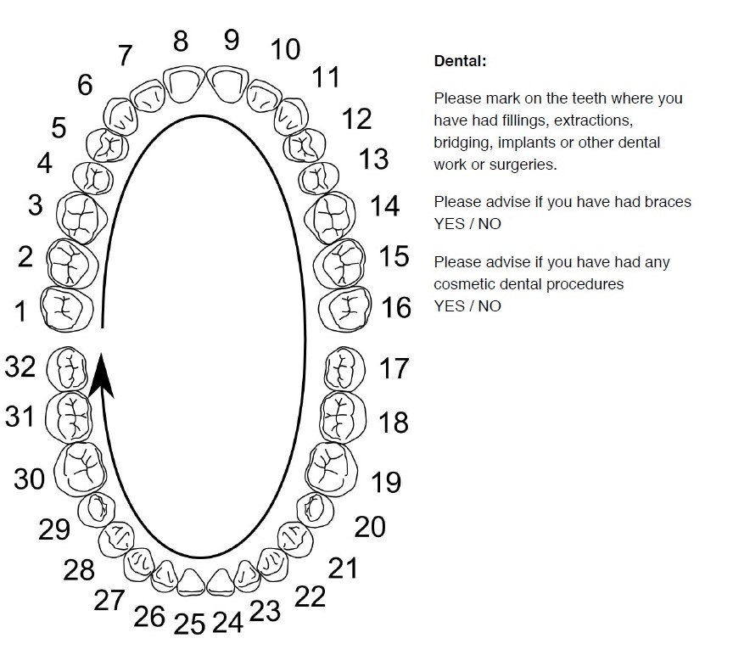

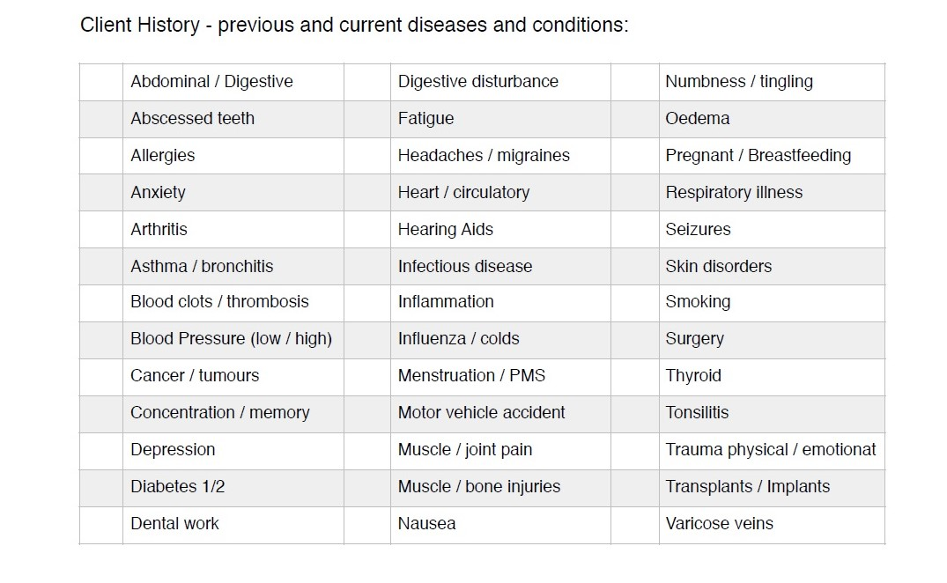

**Scars & Surgeries**

Please mark on these charts where you have had surgeries, injuries, any scars, vaccination scars,

implants, burns or other tissue trauma. Please try to note everything by placing a cross over the

area affected. Even if you think it may be superficial such as a small burn, every piece of

information is important.



**People who are not permitted to undergo testing:**

• If you are pregnant

• If you had a recent heart attack

• If you have a pacemaker

• If you have heart failure

**Please follow the**

**PREPARATION FOR BALANCING WITH**

**BIORESONANCE**

§ Avoid taking alcohol two to three days before your appointment.

§ On the appointment day, avoid taking tea, coffee, chocolate, soft drinks, Coca Cola.

§ Smoking is prohibited 2 hours before the examination.

§ The person must have a bare face.

§ Nails should be unobstructed. (Gellack and Shellack allowed)

§ Do not wear any jewellery

§ Remove the piercing if you have.

§ Wear cotton underwear without metal objects.

§ Do not wear nylon pantyhose.

§ Do not wear a belt with metal objects.

§ Do not use cologne, perfume, hairspray or deodorant.

§ Make sure you eat something lightly one and a half hours before the test.

§ Avoid taking acidic foods (orange, lemon, mandarin) one day before testing.

§ Do not chew gum before and during the examination.

§ Drink at least two glasses of water before testing.

§ Bring the medications you are taking

**Privacy Statement:** In accordance with the Privacy Act, all information held relating to your file is held in total confidence unless otherwise required by law. When appropriate, relevant information regarding your case may be sent to other medical and health care providers for the proper and effective management of your condition.

Do you agree to these conditions? YES / NO

I have read and I understand all of the above information and questions. I have provided true and correct information.

Date_____________________ Print Name ___________________________________

Signed ___________________________________________

**DISCLAMER:** The information in the sessions and related websites and social media is generic for educational purposes and is NOT intended to be taken as any form of medical advice or as a substitute for conventional orthodox medical procedure and care. The content of these sessions is neither intended to diagnose, nor claim to cure or treat diseases, rather than symptom management and address underlying stressors and causes. If symptom persist, consult a qualified health care professional. Collection and use of personal information are subject to our Privacy Policy.